United College of Engineering and Research, Prayagraj

**Department of Computer Science and Engineering**

**Lecture Plan**

|  |  |
| --- | --- |
| **Name of Course** | **PYTHON PROGRAMMING** |
| **AKTU Course Code** | **(KNC-302)** |
| **Branch** | **Computer Science** |
| **Semester** | **3** |
| **Section** | **A** |
| **Total Number of Students** | **68** |
| **Name of Faculty** | **Mr. Abhishek Kesharwani** |
| **Number of Lecture Proposed** | **34** |

|  |  |  |  |  |  |  |  |  |  |
| --- | --- | --- | --- | --- | --- | --- | --- | --- | --- |
| **S. No** | **Unit No** | **Topic** | **CO** | **No of Lectures Required** | **No of Student present** | | **Actual Date of Completion** | **TLM** | **Signature of HOD** |
| **1** | **1** | Python IDE  Interacting with  Python Programs | **1** | **1** |  | |  |  |  |
| **2** | Elements of  Python  Type Conversion | **1** |  | |  |  |  |
| **3** | Basics:  Expressions  Assignment  Statement | **1** |  | |  |  |  |
| **4** | Arithmetic  Operators | **1** |  | |  |  |  |
| **5** | Operator  Precedence | **1** |  | |  |  |  |
| **6** | Boolean  Expression | **1** |  | |  |  |  |
| **No of Lectures Required to complete Unit 1** | | | | **6** |  | **No of Lectures Taken:** | | | |
| **7** | **2** | Conditional statement in  Python  if-else statement  Nested-if  Statement |  | **1** |  | |  |  |  |
| **8** | Elif statement in Python | **1** |  | |  |  |  |
| **9** | Expression  Evaluation | **1** |  | |  |  |  |
| **10** | Loops  While loop  For Loop | **1** |  | |  |  |  |
| 11 | Break and  Continue | **1** |  | |  |  |  |
| **No of Lectures Required to complete Unit 2** | | | | **5** |  | **No of Lectures Taken:** | | | |
| **12** | **3** | Function | **3** | **1** |  | |  |  |  |
| **13** | Execution of a  Function |  | |  |  |  |
| **14** | Keyword and Default  Arguments | **1** |  | |  |  |  |
| **15** | Scope  Rules. |  | |  |  |  |
| **16** | Strings : Length  of the string | **1** |  | |  |  |  |
| **17** | Different string  function |  | |  |  |  |
| **18** | Indexing and Slicing of  Strings. | **1** |  | |  |  |  |
| **19** | Python Data  Structure: Tuples | **1** |  | |  |  |  |
| **20** | Unpacking  Sequences, Lists | **1** |  | |  |  |  |
| **21** | Mutable Sequences, List  Comprehension | **1** |  | |  |  |  |
| **22** | Sets,  Dictionaries | **1** |  | |  |  |  |
| **23** |  | Lambda  Expressions |  | **1** |  | |  |  |  |
| **No of Lectures Required to complete Unit 3** | | | | **9** | **No of Lectures Taken:** | | | | |
| **24** | **4** | Sieve of Eratosthenes: generate prime  number | **4** | **2** |  | |  |  |  |
| **25** | File I/O: File input and output operations in Python  Programming | **1** |  | |  |  |  |
| **26** | Exceptions and  Assertions | **1** |  | |  |  |  |
| **27** | Modules: Introduction, Importing  Modules | **1** |  | |  |  |  |
| **28** | Abstract Data  Types in Python | **1** |  | |  |  |  |
| **29** | Classes: Class  definition | **1** |  | |  |  |  |
| **30** | other operations  in the classes | **1** |  | |  |  |  |
| **31** |  | Class Example,  Inheritance  and OOP. |  | **1** |  | |  |  |  |
| **No of Lectures Required to complete Unit 4** | | |  | **9** | **No of Lectures Taken:** | | | | |
| **32** | 5 | Recursive  Fibonacci |  | **1** |  | |  |  |  |
| **33** | Tower of Hanoi | **1** |  | |  |  |  |
| **34** | Search: Linear &  Binary Search | **1** |  | |  |  |  |
| **35** | Sorting & Merging: Selection  Sort | **1** |  | |  |  |  |
| **36** | Merge List &  Merge Sort | **1** |  | |  |  |  |
| **No of Lectures Required to complete Unit 5** | | |  | **5** | **No of Lectures Taken:** | | | | |

|  |  |  |  |  |  |
| --- | --- | --- | --- | --- | --- |
| **Teaching Learning Methods** | | | | | |
| **TLM1** | **Chalk and Talk** | **TLM4** | **Problem solving** | **TLM7** | **GD** |
| **TLM2** | **PPT** | **TLM5** | **Programming** | **TLM8** | **Case Study** |
| **TLM3** | **Tutorial** | **TLM6** | **Lab Demo** | **TLM9** | **Seminar** |

|  |  |
| --- | --- |
| **Text Books & References** | |
| 1 | Allen B. Downey, ``Think Python: How to Think Like a Computer Scientist‘‘, 2nd edition, Updated for Python 3, Shroff/O‘Reilly Publishers, 2016 (http://greenteapress.com/wp/thinkpython/) |
| 2 | Guido van Rossum and Fred L. Drake Jr, ―An Introduction to Python – Revised and updated for Python 3.2, Network Theory Ltd., 2011. |
| 3 | John V Guttag, ―Introduction to Computation and Programming Using Python‘‘, Revised and expanded Edition, MIT Press , 2013 |
| 4 | Robert Sedgewick, Kevin Wayne, Robert Dondero, ―Introduction to Programming in Python: An Inter-disciplinary Approach, Pearson India Education Services Pvt. Ltd., 2016. |
| 5 | Timothy A. Budd, ―Exploring Python‖, Mc-Graw Hill Education (India) Private Ltd.,, 2015. |
| 6 | Kenneth A. Lambert, ―Fundamentals of Python: First Programs‖, CENGAGE Learning, 2012. |
| 7 | Charles Dierbach, ―Introduction to Computer Science using Python: A Computational ProblemSolving Focus, Wiley India Edition, 2013. |

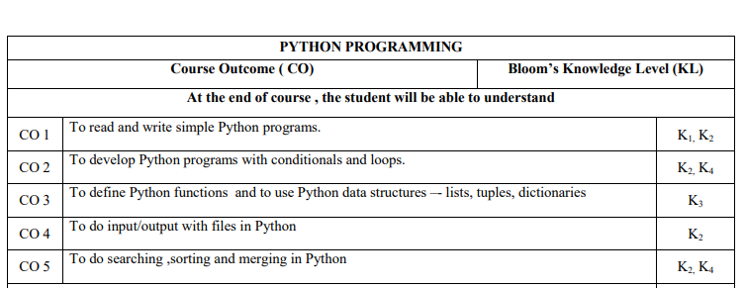

Faculty Instructor Course Coordinator Lecture Plan Incharge Programme Coordinator Head of Department